ESL
This special function allows you to read/write/erase the EEprom of Electronic Steering Lock (ESL / ELV) devices. At the moment the software supports reading/wriitng/erasing ESL units with Motorola processors. This means that the software can be used to unlock the Steering Wheel Lock of the following vehicles: W202, W208, W210, W203, W209, W219, W211.
If you do not have a cable for directly connecting the AVDI interface to the K-Line of the ESL you can check this PDF for creating your own connection: ESL Connection Cable
1. Working with old version of ESL devices
In the following vehicles the ESL is with 2 processors: W202, W208, W210. You can unlock the ESL by erasing its EEPROM. However, for this function to work you must make a direct connection to the ESL via K-line - pin 3 or 4 (pin 3 is the first processor and pin 4 is the second one).
If you erase the EEPROM of the ESL it will unlock automatically. After that you can write it.

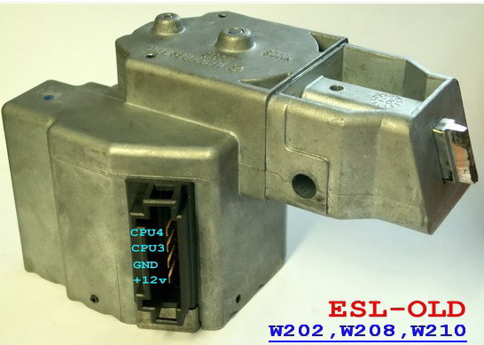

ESL
This special function allows you to read/write/erase the EEprom of Electronic Steering Lock (ESL / ELV) devices. At the moment the software supports reading/wriitng/erasing ESL units with Motorola processors. This means that the software can be used to unlock the Steering Wheel Lock of the following vehicles: W202, W208, W210, W203, W209, W219, W211.
If you do not have a cable for directly connecting the AVDI interface to the K-Line of the ESL you can check this PDF for creating your own connection: ESL Connection Cable
1. Working with old version of ESL devices
In the following vehicles the ESL is with 2 processors: W202, W208, W210. You can unlock the ESL by erasing its EEPROM. However, for this function to work you must make a direct connection to the ESL via K-line - pin 3 or 4 (pin 3 is the first processor and pin 4 is the second one).
If you erase the EEPROM of the ESL it will unlock automatically. After that you can write it.

2. Working with new version of ESL devices
In the following vehicles the ESL is with 1 processor: W203, W209, W219, W211. You can unlock the ESL by erasing its EEPROM. However, for this function to work you must make a direct connection to the ESL via K-line - pin 3.
If you erase the EEPROM of the ESL it will unlock automatically. After that you can write it.

